KIVA Micro Loan Stats – 14 January 2026

- Main Points. EVR has allocated $2,000 to KIVA. A total of $18,700 has been loaned to 311 borrowers in 30 countries throughout the World since 2019. Meaning that for each $1.00 of EVR’s money pledged, it has been re-loaned 9.35 times.

More Detail

- Exe Valley Rotary started lending with KIVA in April 2019
- EVR has invested an initial $1,000 and in 2023 another $1,000 (total $2,000).
- Last loan on 30 Dec 25, we made 9 loans totalling $900.
- Today $191 is in the EVR KIVA account.
- Since the start EVR has made 311 loans to people in 30 different countries.
- Currently 36 people in the World are making monthly repayments.
- The loans have summed up to a total of $18,700.
- So far, $15,511.62 has been repaid by borrowers with $2,751.47 outstanding.
- EVR has lost $336.91 + a donation to KIVA:
  - Currency transaction loss, $188.25.
  - Default total, $148.66.
  - Donation to KIVA, $140.

EVR Rules:
- Initially loans of $25.00 each & then $50.00. From April 2024 started $100 each.
- Selections are made by one of the EVR KIVA team, Tim, Andy Mayne, Andy Harris, Richard Gough, Roy Holman, Joe O’Brien plus Tony Steiner and Garry Berry (for advice if required.) then distributed for comment/agreement.
- Any one person agrees, the loans are made. Time is critical as loans are quickly fulfilled.

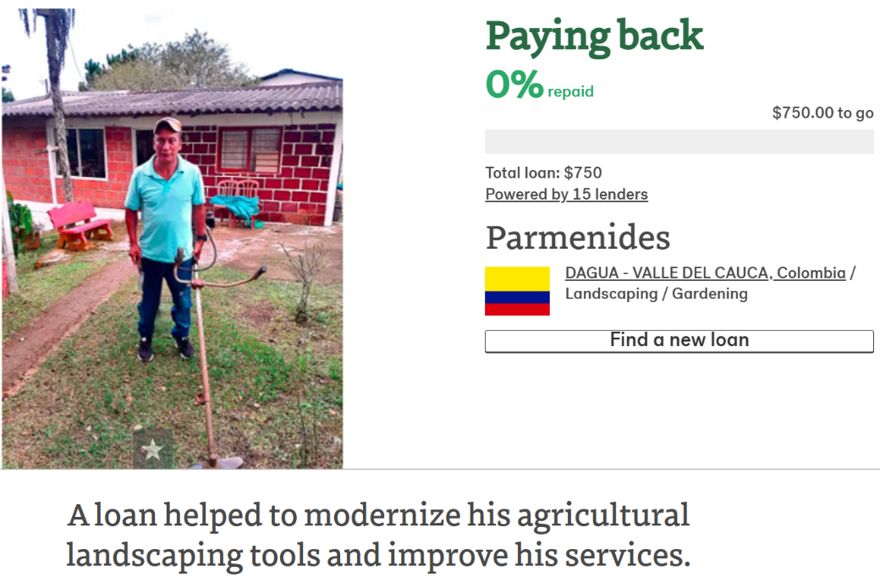
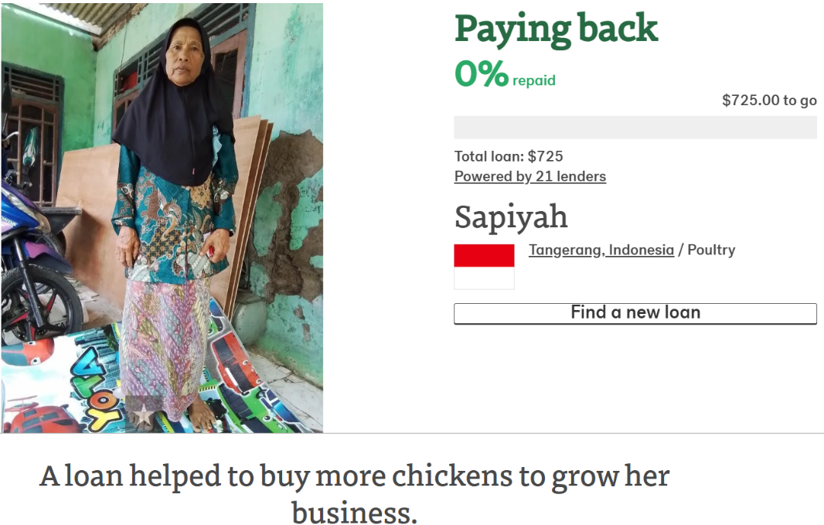 | 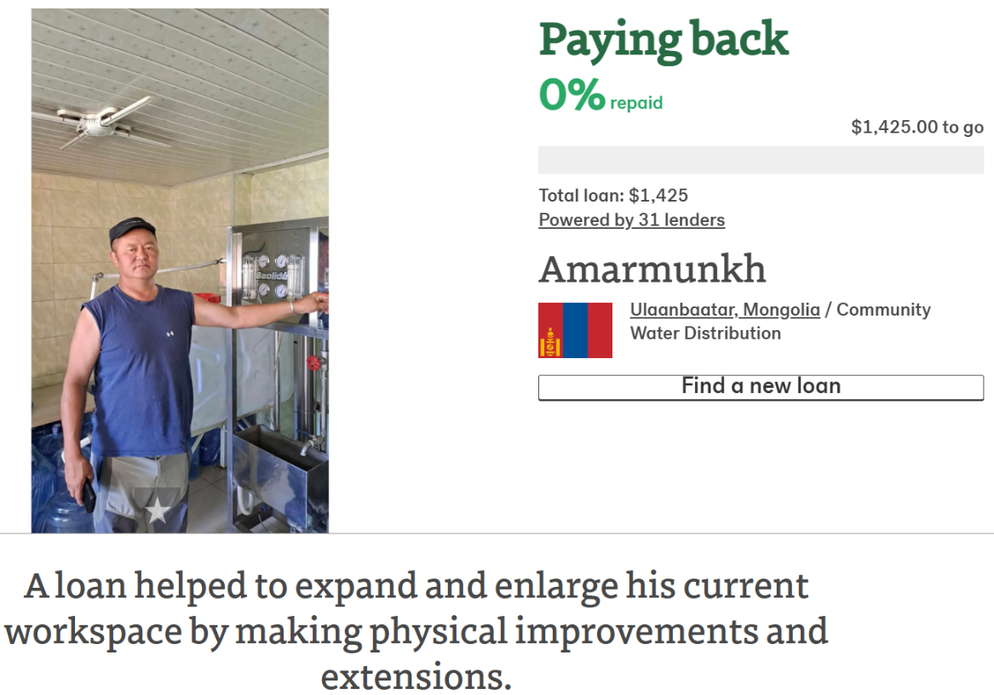
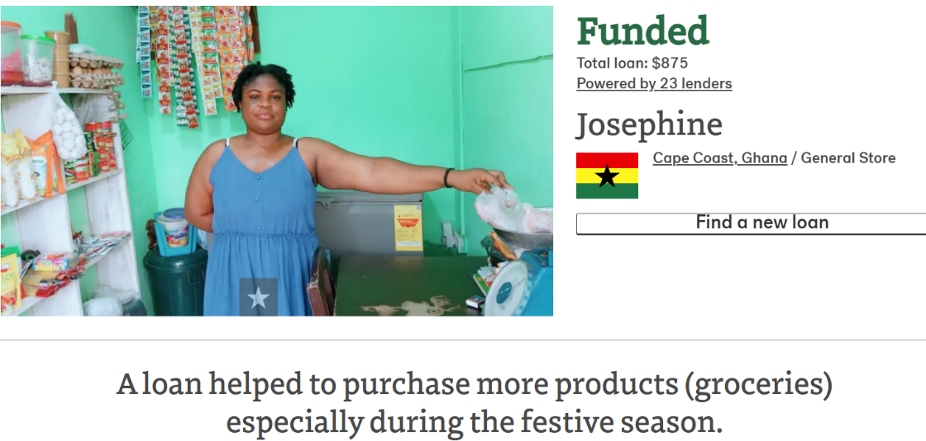 | 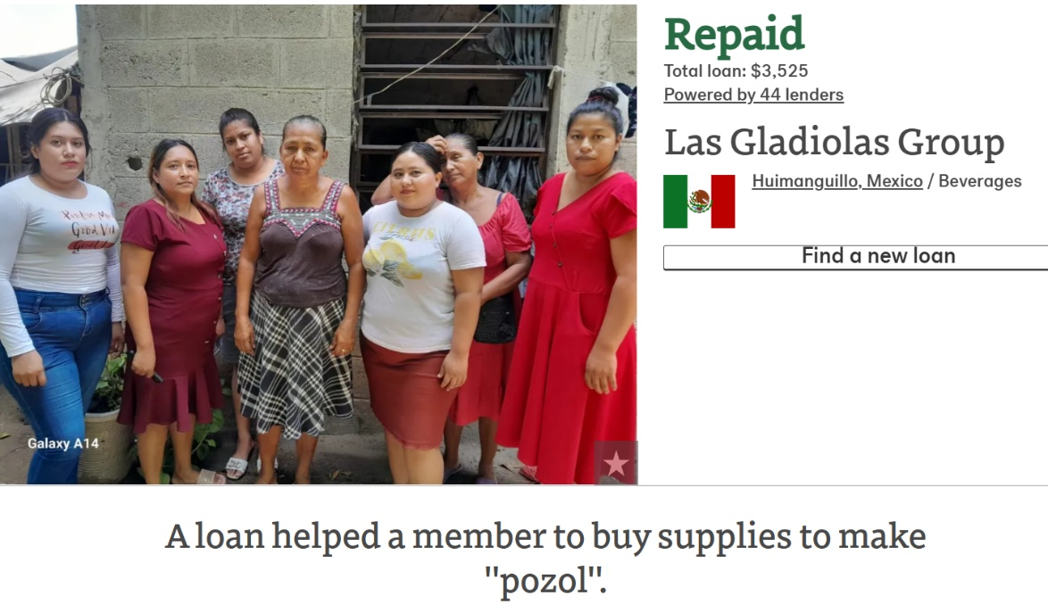
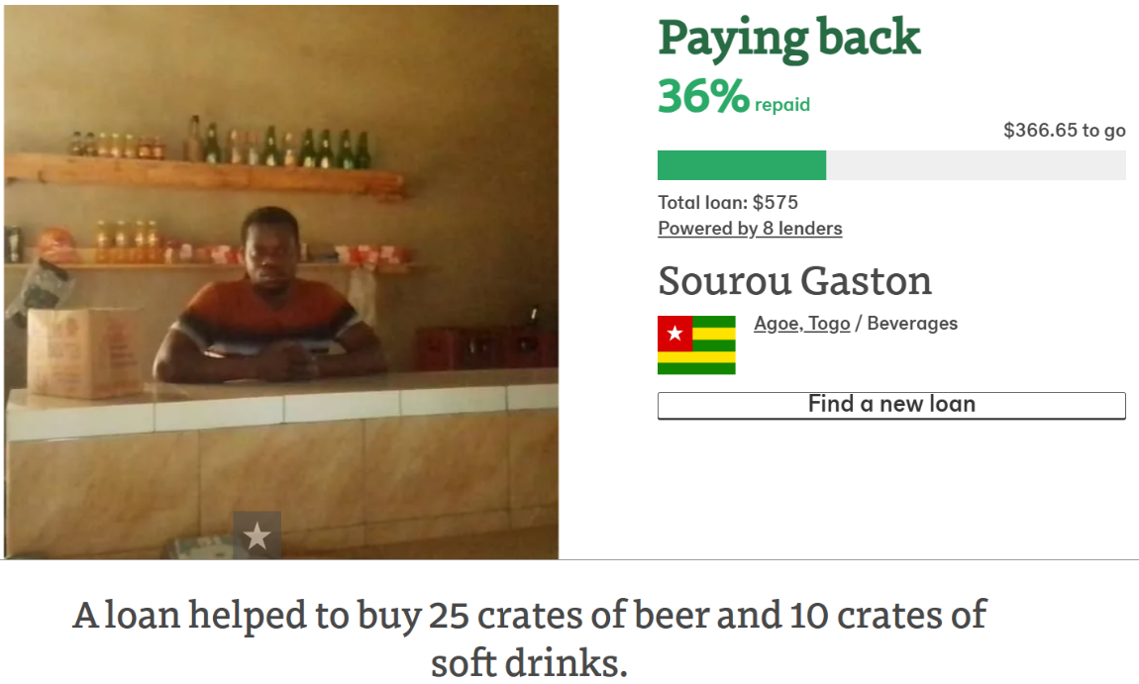 | 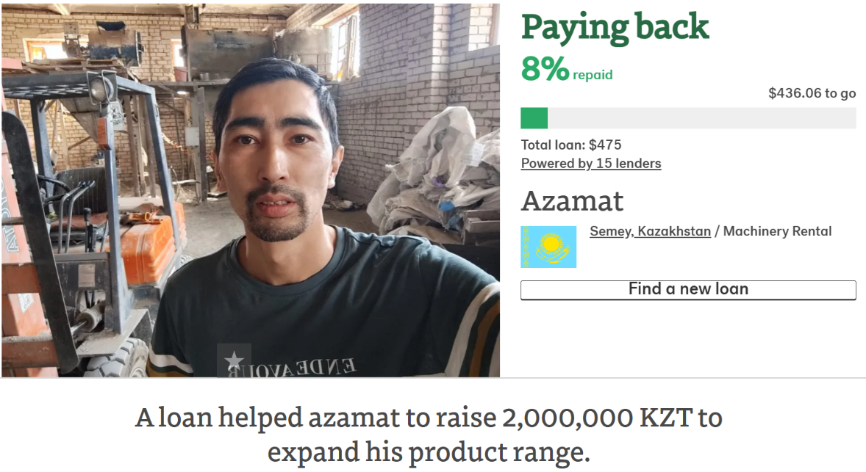
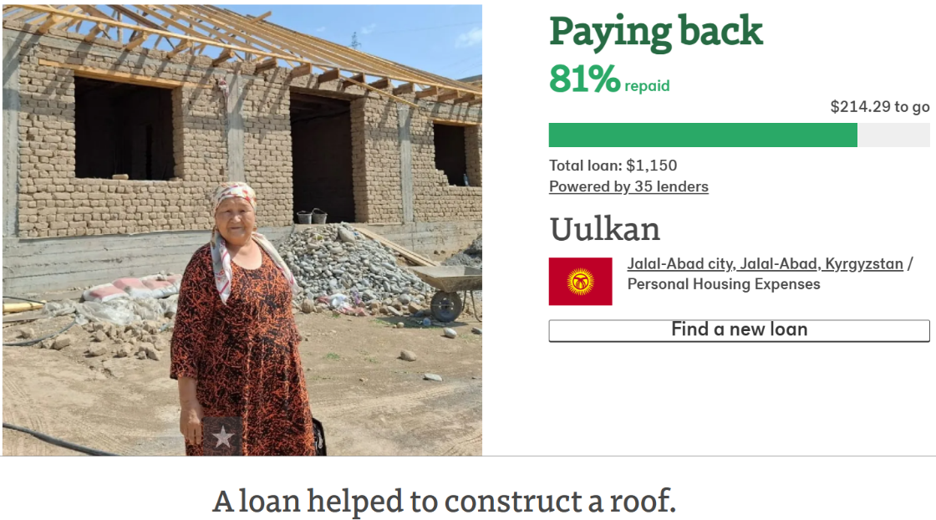 | 